Lllklkl/kk

LIVE THE MUSIC

JJ.KKKK

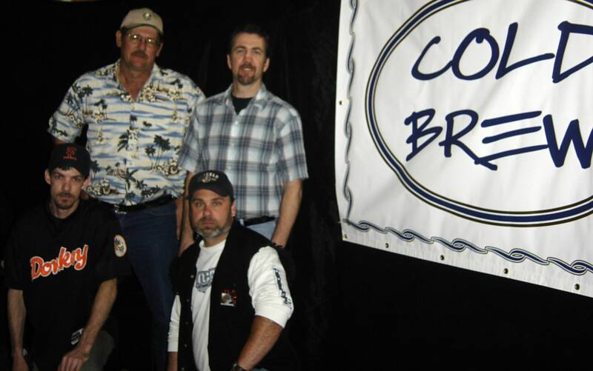

 ROCK & COUNTRY
VARIETY

APPEARING AT: _________________________________

TELL ME WHEN: ________________________________

For bookings and scheduling: www.blueridgeroadshow.com
GIVE IT TO ME NOW!

